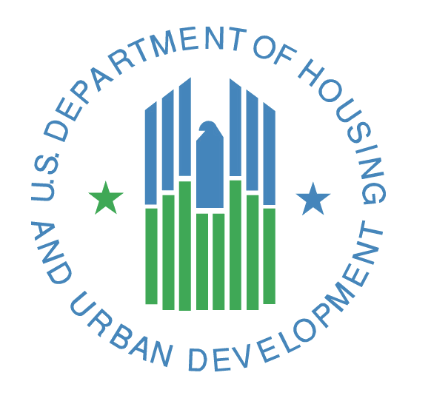

Playing a Critical Role in Boosting Housing Supply:
The Federal Housing Administration and HUD’s Office of Housing

July 14, 2022
Fact Sheet
Too many American households and families are struggling with skyrocketing rents and homeownership that is increasingly out of reach. To ease the burden of housing costs, President Biden released a comprehensive Housing Supply Action Plan in May outlining administrative and legislative actions that will lower housing prices, close the housing supply shortfall in five years, and create hundreds of thousands of affordable housing units in the next three years.
On May 16, 2022, U.S. Department of Housing and Urban Development (HUD) Secretary Marcia L. Fudge traveled to Columbus, Ohio to announce actions in this action plan.
Building on the Administration's housing supply actions, on June 1, 2022, Secretary Fudge launched HUD’s “Our Way Home” initiative to increase affordable housing supply in local communities with a National Day of Action on housing supply.
- Our Way Home is a national initiative to help connect cities, counties, Tribal communities, states, and U.S. Territories to tools and resources that can help preserve and produce affordable housing.

- Our Way Home will amplify best practices and community profiles from urban and rural communities, small and suburban towns, Tribal communities, and U.S. Territories.

- It is going to take government working at all levels and in partnership with non-profit and private organizations to be part of the solution.

HUD is leveraging its Office of Housing, including the Federal Housing Administration (FHA), to facilitate new construction, preserve existing housing stock, and promote greater housing affordability.
- HUD’s Office of Housing and FHA are working at the intersection of housing supply, access to credit, and affordability:

- Office of Housing and FHA programs encompass owner-occupied, site-built homes (including condominiums), manufactured homes, and rental homes.

- FHA is working to removing barriers to homeownership experienced by underserved communities, particularly communities of color. In fiscal year 2021, FHA served 457,489 borrowers who self-identified as borrowers of color and 716,028 first-time homebuyers.

- FHA served double the percentage of Black and Hispanic borrowers compared to the rest of the housing market in 2020 according to the latest available Home Mortgage Disclosure Act data.
- FHA is actively pursuing ways to use its programs to increase both the supply and financing of Accessory Dwelling Units (ADUs). For many – including those in multi-generational homes, non-traditional family structures, or located in high-cost areas –ADUs can offer increased affordability and unlock the potential for wealth-building while expanding the supply of affordable housing.

- Those who live in less expensive or rural areas often find it hard to get a mortgage for a lower-priced home. FHA is actively working to increase the number of FHA-insured, small-balance mortgages.

- HUD will be taking a series of steps to leverage manufactured housing to address both housing supply and affordability:
- The Office of Manufactured Housing Programs administers the Manufactured Home Construction and Safety Standards, commonly referred to as the “HUD Code.” The HUD Code ensures that manufactured homes are built to a high-quality standard of safety and resiliency.

- HUD is finalizing a proposed rule to update the HUD Code, allowing greater production of manufactured homes with features that are demanded by consumers and are more comparable to site-built homes, such as roof pitch designs, open floorplans, and multi-unit dwellings. Other proposed changes will accommodate features sought by consumers seeking safe, modern, energy efficient HUD Code manufactured homes.

- FHA’s Title I manufactured home program provides FHA insurance on loans for manufactured housing, including those titled as personal property. In November 2021, FHA revised its Title I manufactured home and property improvement policies to make them easier to understand and implement for lenders. FHA is actively working on raising the outdated loan limits for this program to fit today’s market.

- FHA also is working to ensure that FHA’s property disposition policies contribute to the supply of affordable inventory for new homeowners.

- FHA revised its Claims Without Conveyance of Title (CWCOT) property disposition program on May 5, 2022, to add a 30-day exclusive sales period for owner-occupants, HUD-approved nonprofits, and governmental entities. The 30-day exclusive period gives these specified buyers an opportunity to bid on foreclosed properties before investors are allowed to participate during the CWCOT post-foreclosure sales period.

- FHA also increased to 30 days the period of time when homeowners, HUD-approved nonprofit organizations, and governmental entities have an exclusive opportunity to bid on most listings of single family homes on HUD’s real-estate owned sale site, HUD HomeStore. The previous exclusive period for these potential bidders was 15 days.

- HUD has held two vacant property note sales during fiscal year 2022 that provided priority bidding opportunities to non-profits and units of local government.

- FHA’s Multifamily mortgage insurance programs are supporting the creation and rehabilitation of affordable rental homes.

- FHA’s Multifamily mortgage insurance program has committed to insuring mortgages for multifamily properties in fiscal year 2022 year-to-date that will create 24,726 new rental homes.

- In partnership with the Treasury Department, last October HUD re-started its Risk Share program with the Federal Financing Bank for state and local Housing Finance Agencies. This program provides low-cost capital to Housing Finance Agencies that enables developers to create and preserve high-quality, affordable rental homes. Since the restart, 22 Housing Finance Agencies are participating in or have applied to participate in the program. FHA has issued 31 firm commitments for mortgage insurance through the program, which will create 8,201 affordable rental homes, with almost two dozen more applications in process.

- HUD’s Multifamily Assisted Housing programs are increasing the supply of deeply affordable rental homes, including those for seniors and persons with disabilities.

- Assisted housing programs administered by HUD’s Office of Multifamily Housing provide rental assistance to some 1.2 million individuals and families with low incomes.

- Supporting vital project-based rental assistance programs is the largest part of the Office of Housing’s portion of the HUD budget, at $13.9 billion enacted for fiscal year 2022. President Biden proposed even more for the program in his fiscal year 2023 budget, totaling $15 billion.

- Through the Rental Assistance Demonstration, HUD’s Office of Multifamily Housing has facilitated more than $14.5 billion in capital investment to improve or replace nearly 175,000 deeply rent-assisted homes, most of which house extremely low-income families, seniors, and persons with disabilities.

- Capital advance and ongoing project-based rental assistance grants under the Section 202 Housing for Very-Low Income Elderly program support the development of new affordable rental homes for seniors. HUD’s Office of Multifamily Housing awarded $143 million in grants under this program in late 2021, supporting the development of approximately 2,100 rental homes and including more than 1,400 that will receive project-based rental assistance.

- Non-profit organizations have accessed $13.4 million in grants through the Office of Multifamily Housing’s Section 811 Supportive Housing for Persons with Disabilities program to build or rehabilitate affordable rental homes for this population. HUD provides rental assistance to more than 35,000 households through the Section 811 program.

- In addition to FHA’s efforts to drive more housing supply, HUD continues to make progress on other commitments made in the Administration’s Housing Supply Action Plan.

- The HOME Investment Partnership Program is the largest federal block grant to state and local governments, designed exclusively to create affordable housing for low-income households. HUD will work to strengthen and streamline the HOME program through rulemaking to optimize this critical resource for affordable housing for renting and homeownership.

- HUD will also provide technical assistance, peer learning opportunities, and/or listening sessions on core HUD supply programs. One example of this work is showing localities how the Community Development Block Grant (CDBG) can be used for local acquisition as a strategy to preserve affordable housing and counter the growing trend of large institutional investors purchasing large shares of local housing supply, including encouraging sales to local community organizations and mission driven developers.
About the Office of Housing and FHA
- FHA mortgage insurance programs have facilitated affordable home financing or refinancing for 692,259 individuals and families this fiscal year alone through May 2022. FHA has active mortgage insurance on some 7.2 million single family forward mortgages and more than 398,000 Home Equity Conversion (reverse) mortgages as of May 31, 2022.

- Approximately 84 percent of FHA-insured forward mortgage purchase transactions this fiscal year supported first-time homebuyers.

- FHA enabled 44,641 senior homeowners to age in place in their own homes through its Home Equity Conversion Mortgage reverse mortgage program so far this fiscal year.

- FHA endorsed 720 mortgages for multifamily properties this fiscal year through May 2022 and 217 mortgages for residential care facilities and hospitals.

- The Office of Housing Counseling, part of HUD’s Office of Housing, supports a network of more than 1,500 HUD-participating housing counseling agencies to advance sustainable homeownership and stable and affordable rental housing.
###
HUD's mission is to create strong, sustainable, inclusive communities and quality affordable homes for all.
More information about HUD and its programs is available at www.hud.gov and https://espanol.hud.gov.
You can also connect with HUD on social media and follow Secretary Fudge on Twitter and Facebook or sign up for news alerts on HUD's Email List.
HUD COVID-19 Resources and Fact Sheets

